Literature Review
As we already know Transformer (2017) architecture in class, in Natural Language Processing (NLP), the paradigm was revolutionized by BERT (Devlin et al., 2018), which introduced Masked Language Modeling (MLM). By masking a small portion of the input text and training the model to predict the missing words, BERT demonstrated the immense power of autoencoding for pre-training.
However, translating this success to Computer Vision (CV) was initially challenging due to architectural differences and the dense, highly redundant nature of image pixels. The architectural barrier was fundamentally lowered by the Vision Transformer (ViT) (Dosovitskiy et al., 2020). By dividing an image into a sequence of non-overlapping patches and processing them with a standard Transformer, ViT provided a sequence-based representation of images, making NLP-like self-supervised tasks structurally feasible in vision.
Prior to Masked Image Modeling (MIM), CV Self-supervised learning (SSL) was heavily dominated by contrastive learning methods that we have already learned in Lecture 10. While effective, these methods relied heavily on carefully engineered, complex data augmentation pipelines to create positive and negative sample pairs. The focus article, Masked Autoencoders (MAE), represents a paradigm shift away from contrastive learning towards generative MIM. As highlighted in the comprehensive survey by Zhang et al. (2022), MAE established a foundational framework that successfully adapted the MLM philosophy to vision, proving that simple reconstruction tasks could yield highly transferrable representations.

Contributions and Improvements over Existing Methods
- Asymmetric Encoder-Decoder Architecture for Scalability
The most significant architectural contribution of MAE is the decoupling of the encoder and decoder. A lightweight decoder then processes the encoder's latent representations alongside mask tokens to reconstruct the original image.
- High Masking Ratio Addressing Information Redundancy
Unlike BERT in NLP, which typically masks only 15% of tokens due to the high information density of language, MAE employs an aggressively high masking ratio of 75%. The authors identified that images are highly redundant; if the masking ratio is too low, the model can solve the task through simple low-level pixel interpolation.
- Simplification of the Pre-training Pipeline
Before MAE, state-of-the-art CV SSL required complex data augmentations, massive batch sizes, and memory banks. MAE completely abandons these requirements. It relies on a straightforward generative task—reconstructing raw pixel values using a simple Mean Squared Error (MSE) loss on the masked patches.
The profound impact of MAE has inspired numerous extensions. For instance, while the original MAE relies on random patch masking, subsequent works like SemMAE (Li et al., 2022) introduced semantic-guided masking strategies.

Methodology: From Sequence Processing to Masked Image Modeling
The architecture follows an interesting route: from the original Transformer to the ViT, and finally to the MAE framework.
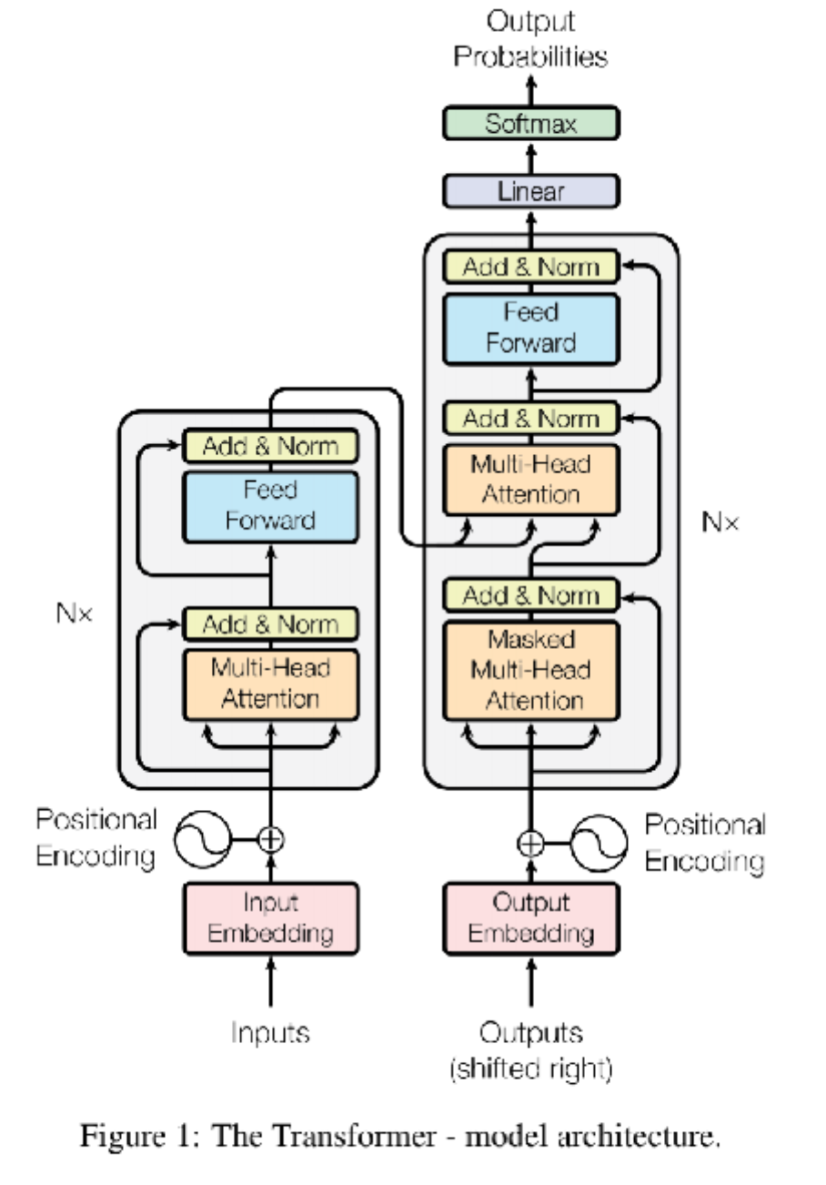 | 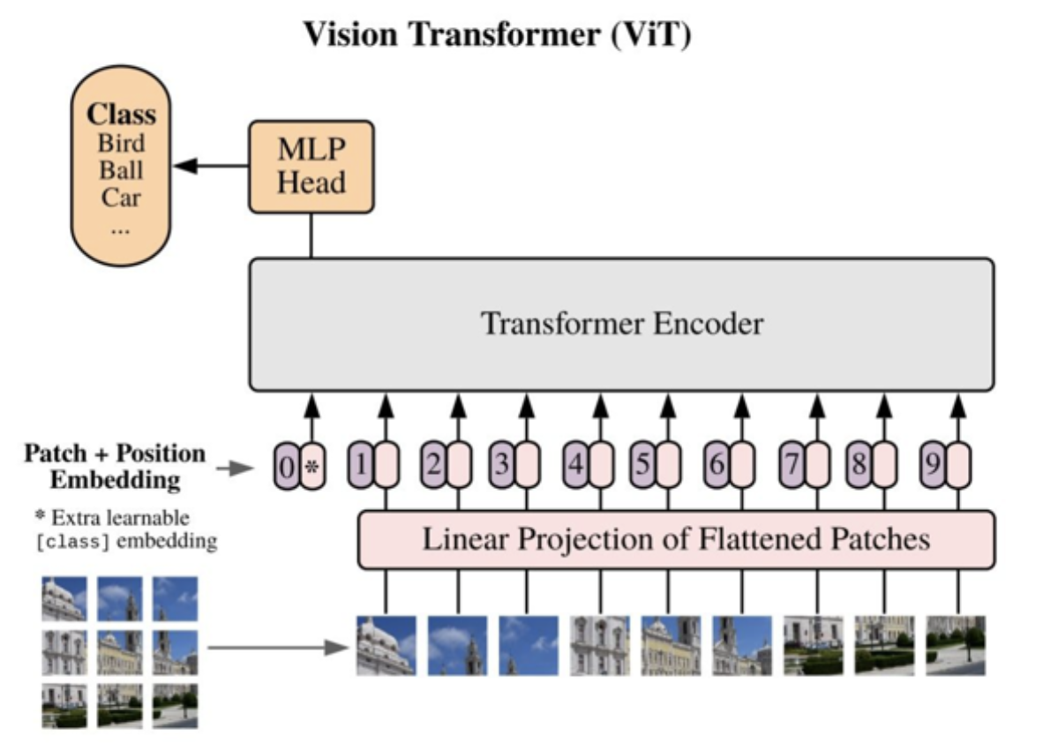 | 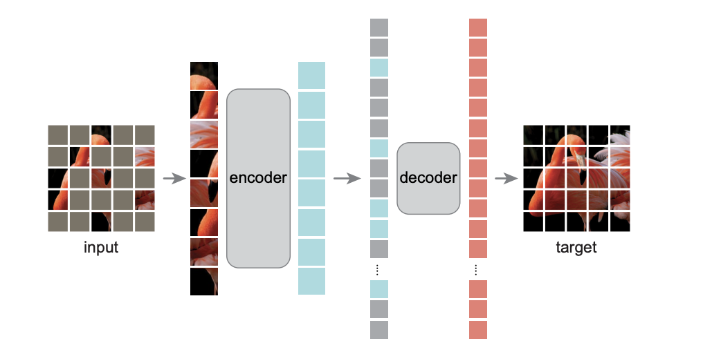
Transformer | Vision Transformer | MAE

The Conceptual Bridge: From Transformers to ViT
The Transformer architecture was originally designed for NLP to process sequential data (words) using a self-attention mechanism, which excels at capturing long-range global dependencies. However, translating this to images was historically difficult because images are grids of pixels, not 1D sequences.
The ViT bridged this gap by treating an image exactly like a sentence. An image of size $H ×W ×C$ is divided into a grid of non-overlapping patches ($16 ×16$ pixels per patch in paper example). These patches are linearly projected into 1D vectors called "Patch Embeddings". Because the self-attention mechanism is permutation-invariant, Positional Embeddings are added to these patches to retain spatial information. This flattened sequence of patches is then fed into a standard Transformer block.

The MAE Architecture: Asymmetric Autoencoding
Building upon the ViT backbone, the focus article introduces MAE. The methodology operates through a highly optimized, asymmetric encode-decode process:
- Step 1: Aggressive Random Masking
The input image is divided into patches following the ViT approach. A remarkably high proportion—typically 75%—of these patches are randomly masked out. This high masking ratio is a critical working detail: unlike text, images contain heavy spatial redundancy. If only a few patches are masked, the model can "cheat" by interpolating nearby pixel values. Masking 75% forces the model to learn deep, holistic semantic representations of the objects to reconstruct the missing parts.
- Step 2: The Heavyweight Encoder
The MAE Encoder is a standard, large-scale ViT. However, it operates strictly on the 25% visible, unmasked patches. This is the core engine of MAE's scalability. By ignoring the masked tokens entirely, the computation and memory footprint are reduced to a fraction of a standard ViT, allowing for the training of massive models efficiently. The encoder maps these visible patches into rich latent representations.
- Step 3: The Lightweight Decoder
The decoder's job is to reconstruct the original image. Its input consists of the encoded visible patches and Mask Tokens.
- Additional Detail
A mask token is a shared, learnable vector that indicates the presence of a missing patch to be predicted. Crucially, full positional embeddings are added to all tokens in this decoder phase. Without this, the mask tokens would have no information about their original location in the image grid.
Since the decoder only performs the reconstruction task during pre-training, it can be designed to be much narrower and shallower than the encoder, further significantly reducing computation time.

Reconstruction Target and Loss Function
The output of the decoder is a tensor representing the predicted pixel values for each patch. The loss function computes the Mean Squared Error (MSE) between the reconstructed pixels and the original image pixels:
$$MSE=\frac{1}{M}\sum_{i∈\text{masked}}{{\left(x_{i}-\hat{x_{i}}\right)}^{2}}$$
Where $x_{i}$ represents the original pixel values and $\hat{x_{i}}$ represents the predicted pixel values. A vital methodological detail is that the loss is calculated only on the masked patches, identical to BERT's logic. Computing loss on the visible patches would encourage the model to waste capacity memorizing the input rather than learning to predict the unseen.

Examples
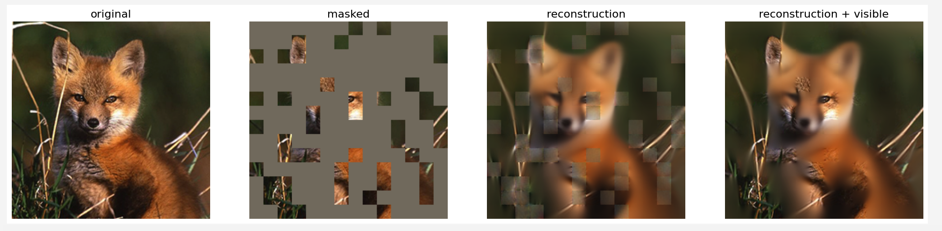
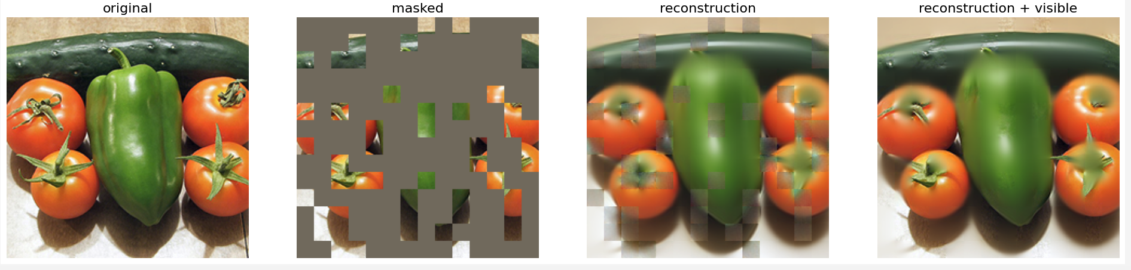
From the code demo provided by the paper team in Github, we can run and output two examples as listed above.
- Original: 100% real picture, the whole picture.
- Masked: the visible part for encoders to input, which means the model uses 25% to predict the remaining 75% part.
- Reconstruction: the output from the decoders.
- Reconstruction + Visible: 25% part used in encoder + 75% part from the decoder.
Using the pre-trained model provide in Github, we can see clearly that the method is very powerful. The model is well trained and the prediction accuracy for the unmasked parts is very high.

Literature involved
1. Devlin, J., Chang, M.-W., Lee, K. and Toutanova, K. (2019). BERT: Pre-training of deep bidirectional transformers for language understanding. Proceedings of the 2019 Conference of the North American Chapter of the Association for Computational Linguistics: Human Language Technologies, Volume 1, pp. 4171–4186.
2. Dosovitskiy, A., Beyer, L., Kolesnikov, A., Weissenborn, D., Zhai, X., Unterthiner, T., Dehghani, M., Minderer, M., Heigold, G., Gelly, S., Uszkoreit, J. and Houlsby, N. (2021). An image is worth 16x16 words: Transformers for image recognition at scale. Ninth International Conference on Learning Representations.
3. He, K., Chen, X., Xie, S., Li, Y., Dollár, P. and Girshick, R. (2022). Masked autoencoders are scalable vision learners. Proceedings of the IEEE/CVF Conference on Computer Vision and Pattern Recognition, pp. 16000–16009.
4. Li, G., Zheng, H., Liu, D., Wang, C., Su, B. and Zheng, C. (2022). SemMAE: Semantic-guided masking for learning masked autoencoders. Advances in Neural Information Processing Systems, 35, pp. 14290–14303.
5. Zhang, C., Zhang, C., Song, J., Yi, J. S. K., Zhang, K. and Kweon, I. S. (2022). A survey on masked autoencoder for self-supervised learning in vision and beyond. Proceedings of the 31st International Joint Conference on Artificial Intelligence, pp. 5664–5671.

